How to update Sunsynk inverter with the Irish firmware version
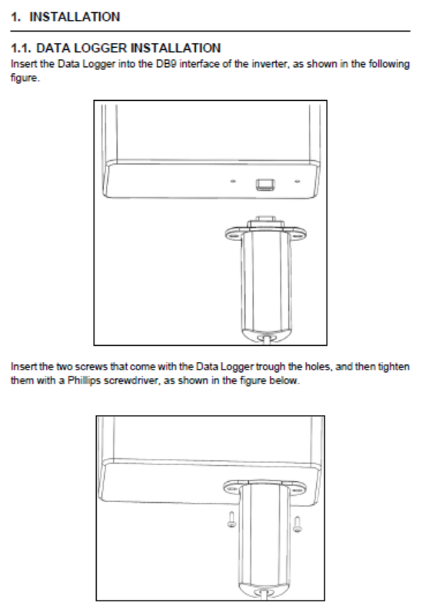
Please note, the first 7 pages are copied from the data logger manual to outline how to setup the Sunsynk data logger with the Sunsynk hybrid inverter.

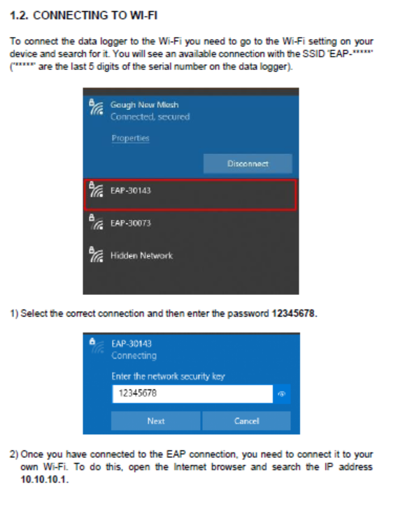

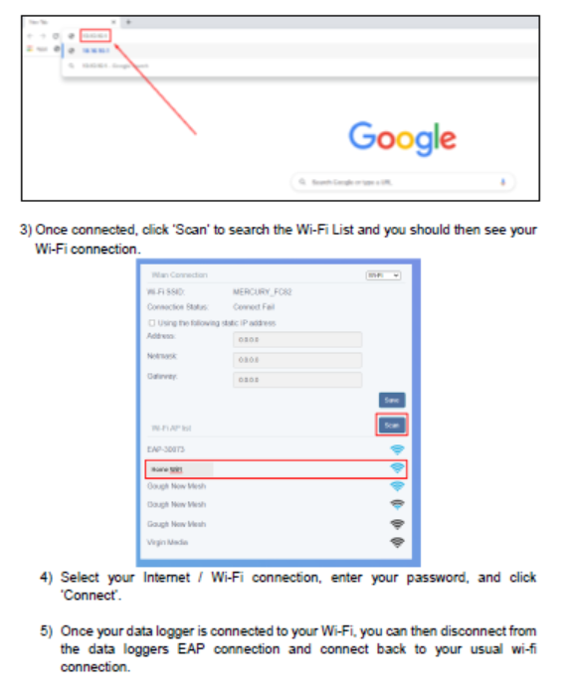

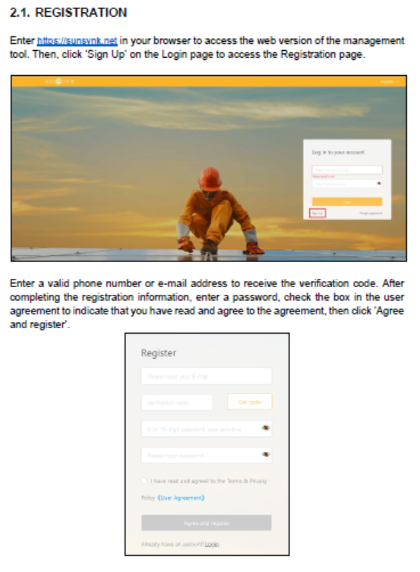

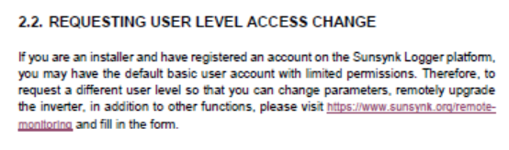
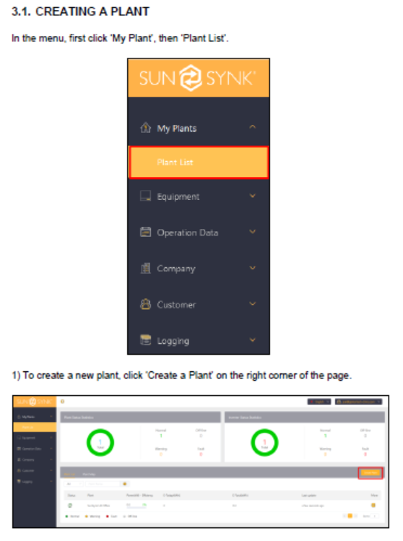
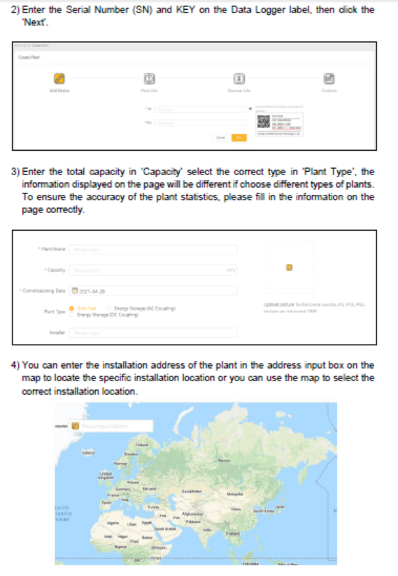
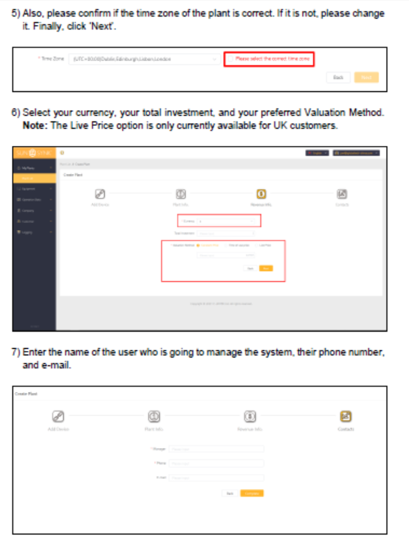

The following pages are outlining how to update the firmware using the Sunsynk data logger and web app
Once you have the data logger successfully connected, you can now force out an update to the inverter with the Irish firmware.
- On the Sunsynk web app, go to firmware then inverter firmware
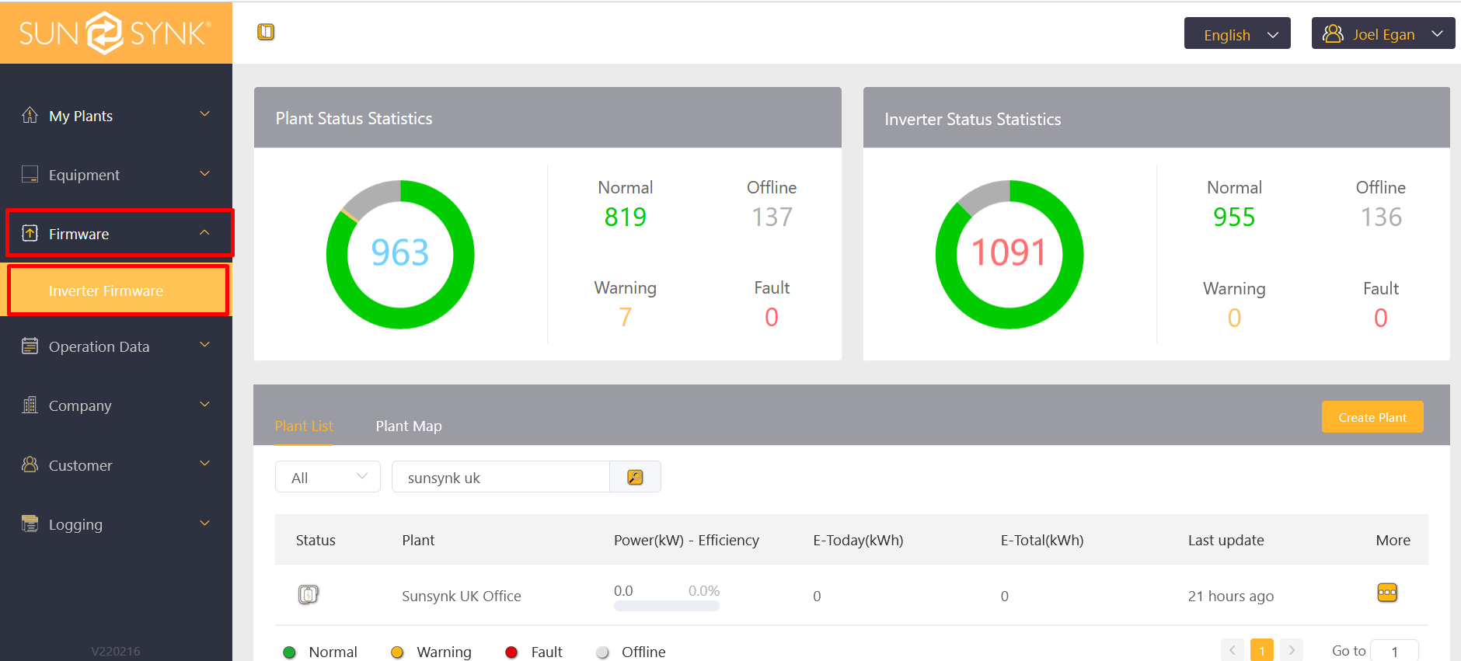
- On the inverter firmware page, select publish
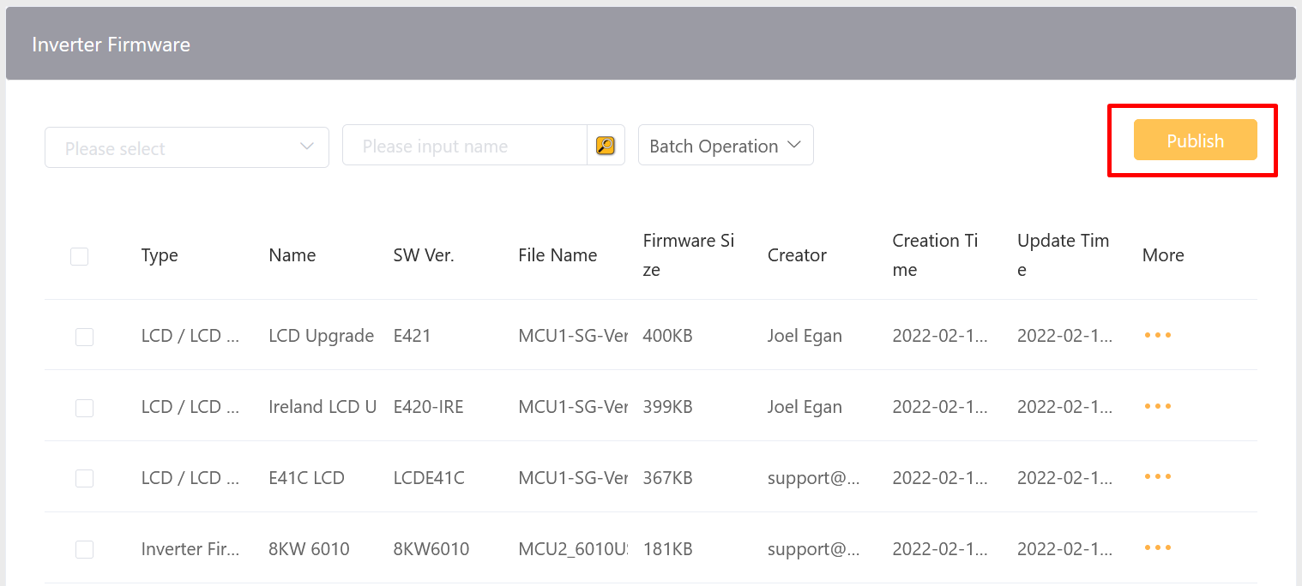
- Complete the essential information on the page and then select the settings cog next to “Type”
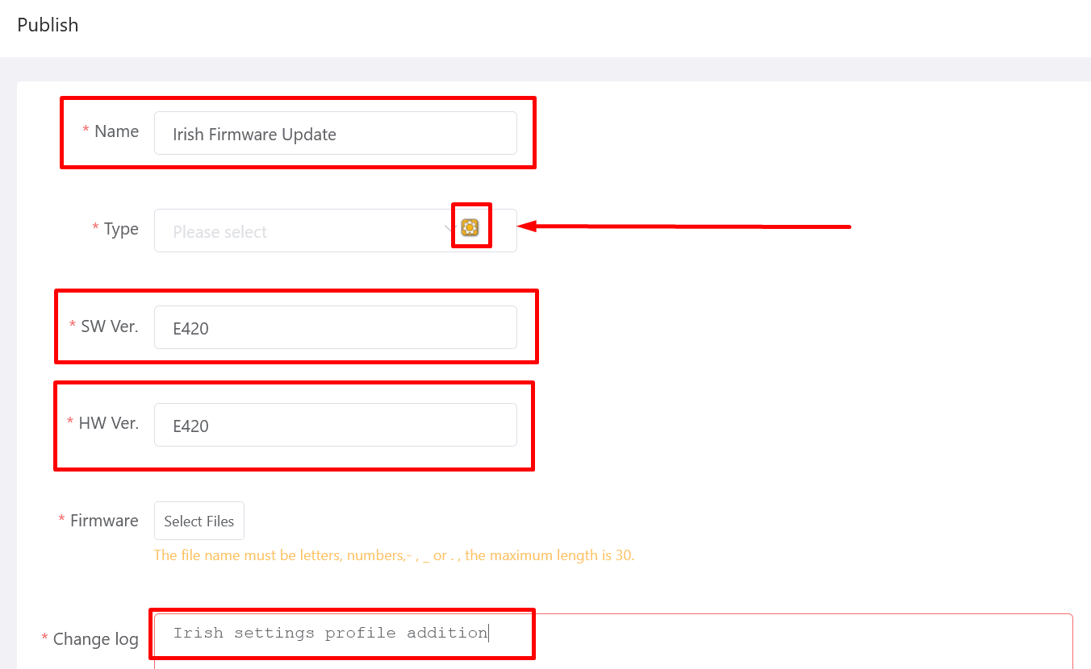
- Click add new primary label and give it a name
- Click add secondary label and give it a name.
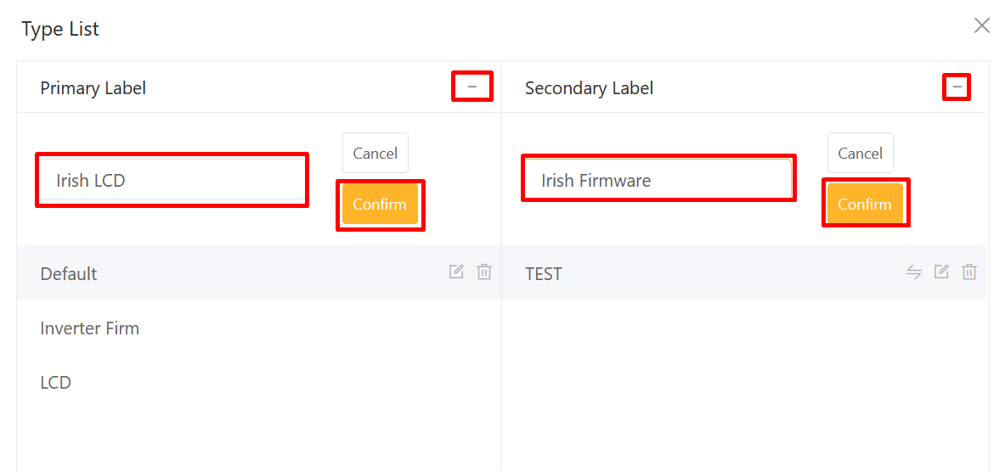
- Once you have added the type, select it from the drop-down list and then select the firmware files
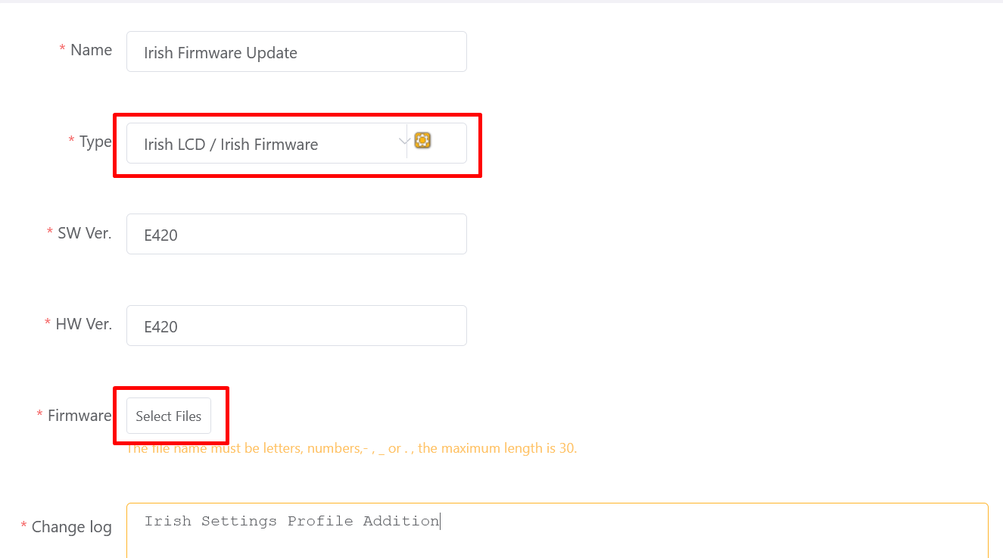
- Select the Irish firmware upgrade and then click open
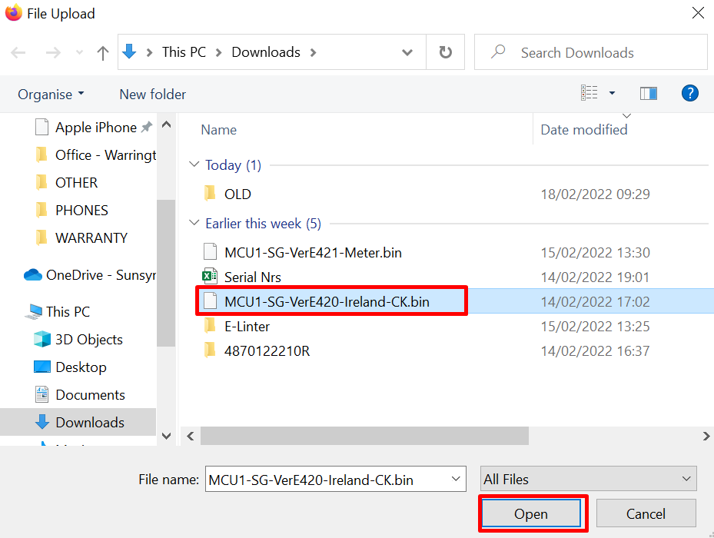
- Click confirm
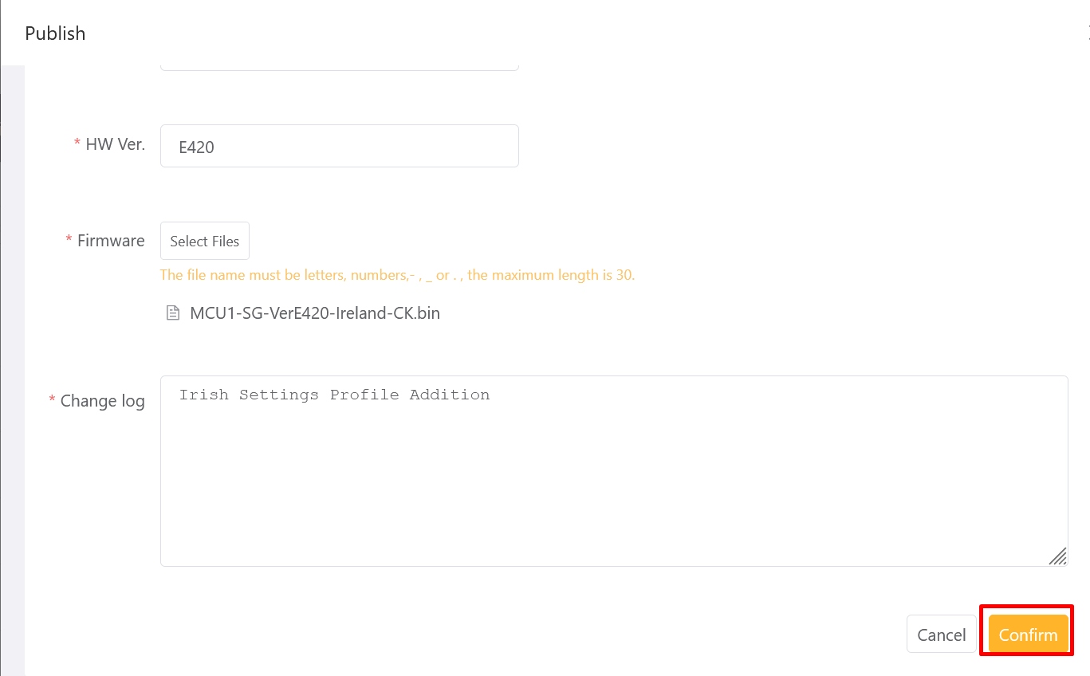
- Next, go to equipment and then inverter
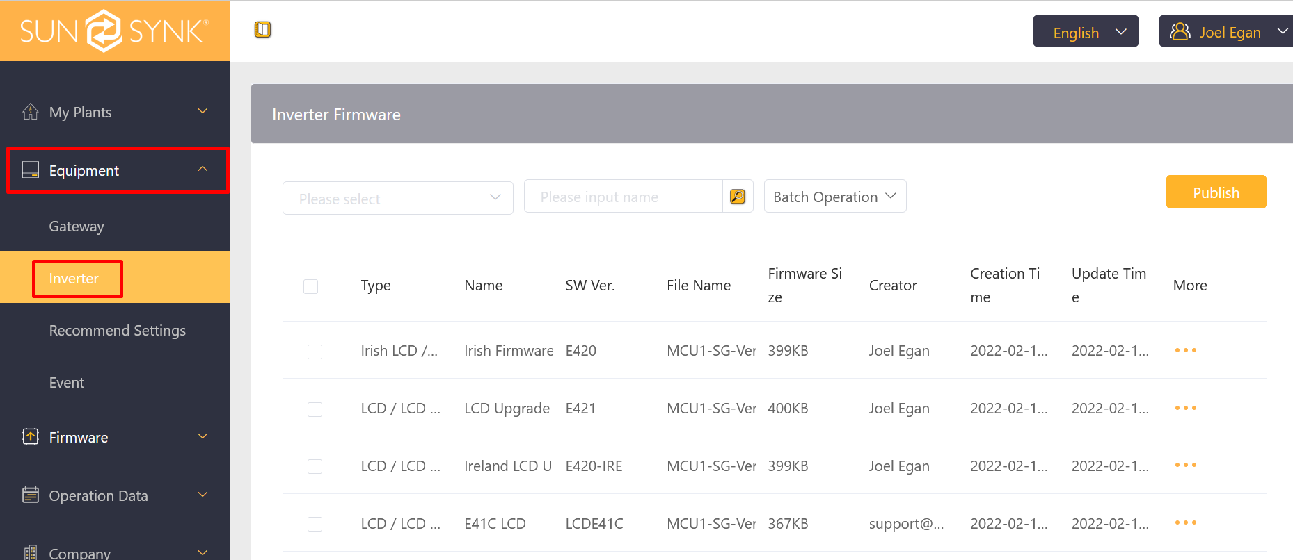
- Next to the inverter you want to upgrade, select more and then Upgrade
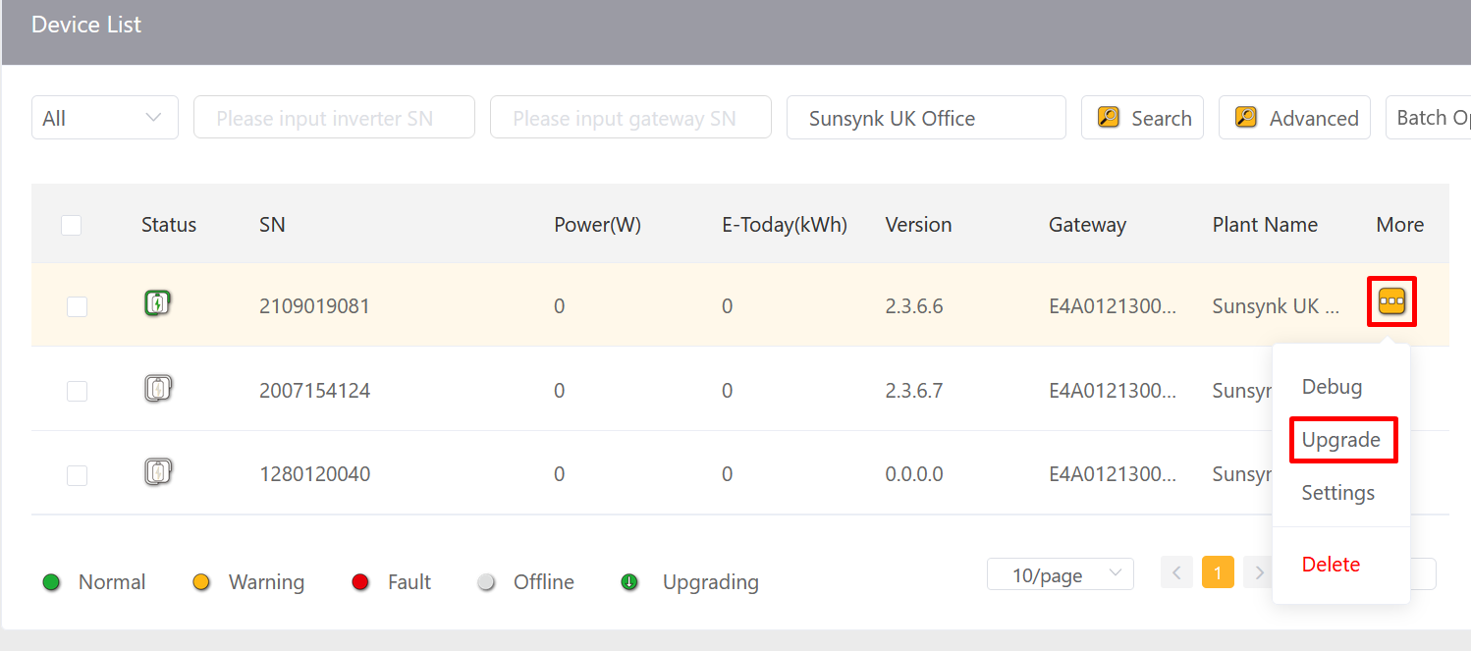

- Select the firmware type and then select the type you have just created.
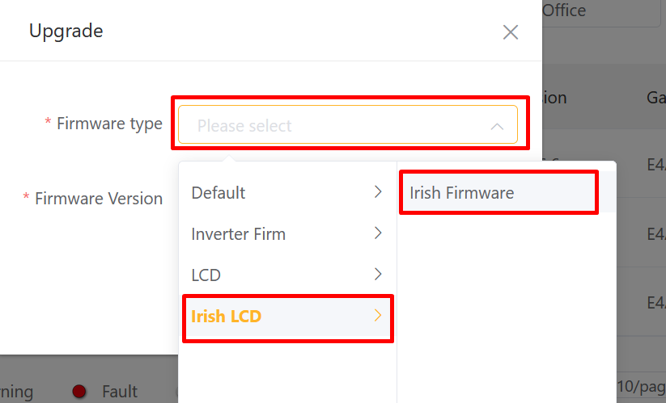

- Finally select the version and click confirm.
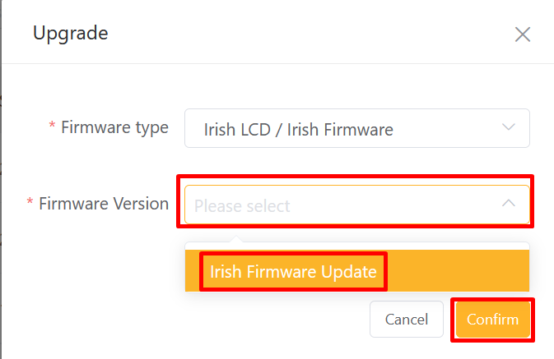
- You can track the progress of your upgrade by clicking the status next to the inverter.
