When SoC drops 0% and the communication could not be established automatically, what to do?
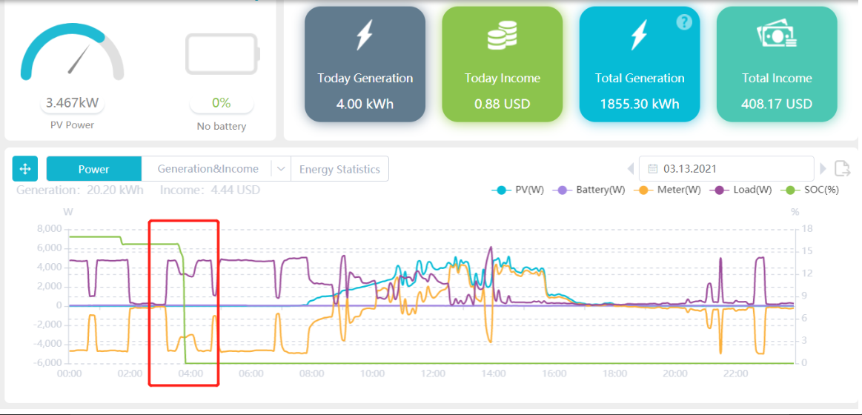
Before checking the battery and communication cable status, please restart the system (including batteries and inverter) without making any change to the system.
Do not unplug the communication cable, just restart the battery and the inverter.
If battery can communicate to the inverter again without any change, this is a software issue, please contact inverter engineer to update firmware to the latest version.
If battery can not communicate to the inverter, then please unplug these cable and restart again, if this works, that means something wrong with cables. Please tighten cables again.

